The Segment Tool
Update – May 2016
Guidance on use, interpretation and frequently asked questions

- Introduction
This paper provides guidance on how to use The Segment Tool, which was first published by Public Health England (PHE) in January 2014, and most recently updated in May 2016. It also provides advice on how to interpret the outputs and answers to a set of frequently asked questions.
The May 2016 update of the tool provides data for a more recent time period, and incorporates some small changes to the data sources used. The changes are:
- Update of data to 2012-14
- Update to use the new Index of Multiple Deprivation 2015 to define the most and least deprived areas
- Adjustment of counts of deaths to take account of changes in ICD-10 coding made in 2014
Because of these changes, the results in this version of the Segment Tool are not directly comparable with previous versions.

- Purpose
The tool has been developed by PHE’s Epidemiology and Surveillance Team and provides information on the causes of death driving inequalities in life expectancy at local area level. Identifying and targeting the causes of death which contribute most to life expectancy gaps should have the biggest impact on reducing inequalities.

- What does this tool do
The tool segments life expectancy gaps by cause of death, using data for 2012-14. There are currently two comparisons available:
1. The gap between the local authority as a whole and England as a whole.
2. The gap between the most deprived quintile of the selected area and the least deprived quintile of the local authority.
The tool segments by cause of death the life expectancy gap between the area selected and the comparator, and displays the results in charts and tables.
Once a comparison has been selected, the tool presents four charts, each segmenting the life expectancy gap in a slightly different way.
Scarf charts show, for each of eight broad causes of death (including cancer, circulatory disease and respiratory disease), the percentage contribution that it makes to the overall life expectancy gap between the areas selected. For comparison 1 (local authority as a whole to England as a whole), scarf charts are only available for areas where the life expectancy in the local authority is lower than the life expectancy in England (ie where there is a gap to segment). For comparison 2, scarf charts are only available for areas where the life expectancy in the most deprived quintile is lower than life expectancy in the least deprived quintile.
Bar charts for the broad causes of death show the number of years of life expectancy that would be lost or gained if the selected area had the same age specific mortality rates as the comparator for each cause. Since these charts include both years of life lost and years of life gained, they are available for all areas.
Bar charts for more detailed causes of death allow users to drill down and view the number of years of life that would be lost or gained for a number of more detailed causes of death within each broad category. These charts are available for all local authority areas.
Finally, users can view bar charts for alcohol specific deaths, which show the number of years of life that would be gained or lost if the selected area had the same age specific mortality rates for alcohol specific deaths (deaths which are wholly attributable to alcohol) as the comparator area. This is the first of a number of lifestyle based causes of death that may be included in the Segment Tool.
Beneath each chart,a corresponding data table can be found showing the total number of deaths from each cause, the number of excess deaths, and the percentage contribution that each cause makes to the life expectancy gap. Excess deaths are the number of ‘extra’ deaths occurring in the area for the cause, compared to the number of deaths that would be expected if the mortality rate for the cause was the same as the comparator area.

- How to access the tool
The tool is in an Excel spreadsheet, which can be downloaded from fingertips.phe.org.uk/profile/segment. No password or login details are required to access the tool. A summary report for each local authority, English region and England as a whole is also available.

- How to use the tool
The tool uses macros. If your macros are disabled in Excel, you will need to enable them before using the tool.
From the front page, click on ‘start using the tool’. You will be taken to the selection page:

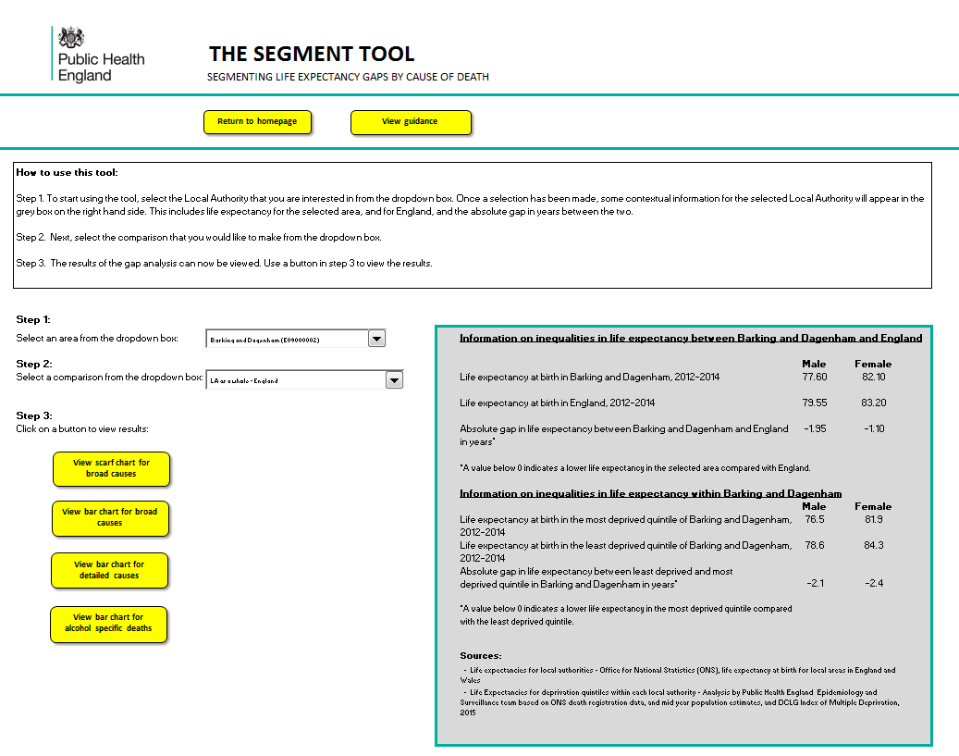

Select the local authority that you are interested in. When a local authority is selected, contextual information is provided for that area in the grey box on the right hand side of the page. This includes the current life expectancy in the selected area and in England, and the absolute gap between them.
Next, select the comparison that you are interested in. This will either be the gap between the local authority as a whole and England as a whole, or the gap between the most deprived quintile of the local authority and the least deprived quintile of the local authority. The contextual information in the grey box should be used to guide you as to which comparator to select. The gap between the local authority and England is likely to be most useful to areas where the life expectancy is lower than England. However, data are available for all areas, since even in areas with a higher life expectancy that England there may be specific causes of death which are causing a reduction in life expectancy which could be targeted locally.
Choose one of the four charts to view. Once a local authority and comparison has been selected, the results can be viewed by clicking a button in step 3. We recommend beginning by looking at the broad causes of death, before looking at the more detailed options.
To select another area, comparison or chart type, click on the ‘change selection’ button at the top of the screen to return to the selection screen. Guidance on using the tool and interpreting the results is also available from within the tool by clicking on the ‘View guidance’ button.

- How to interpret the charts and tables

- Scarf chart for broad causes
This sheet shows the contribution of each of eight broad causes of death to the life expectancy gap between the selected area (the base area) and the comparison (the comparator area). Depending on which option has been selected, the base area could be the local authority as a whole, and the comparator area England; or the base area the most deprived quintile in the local authority, and the comparator area the least deprived quintile in the local authority. Data are only available in this sheet if the base area has a lower life expectancy than the comparator area.
The table shows the results of the analysis. For each cause of death, the number of excess deaths occurring in the base area are presented. Excess deaths are the number of ‘extra’ deaths that occur in the base area compared to the number of deaths that would occur if the base area had the same mortality rate as the comparator area for that cause.
For causes where the mortality rate is higher in the base area than in the comparator, applying the comparator mortality rate increases the potential life expectancy for a base area. This allows us to calculate the additional years of life that would be gained if the base area had the same mortality rate for the cause of death as the comparator area. When the additional years of life have been calculated for all the causes of death in the base area, they can be summed to give a total number of additional years of life.
The percentage contribution to the gap can then be calculated for an individual cause of death by dividing the extra years of life for an individual cause of death by the extra years of life for all causes of death. The percentages in the table show how much each cause of death contributes to this gap.
Negative values, where mortality in the base area is actually lower for a specific cause than the comparator area, are excluded from the table, and do not contribute towards the calculation of the life expectancy gap. These results are shown as ‘..’ in the table.
The gap in life expectancy is broken down so that the percentage contribution of causes will sum to 100 per cent. For some base areas, particularly where the overall gap in life expectancy between the base and the comparator is quite narrow, or where only a few causes have excess mortality, care should be taken in interpreting the results. Some causes of death may be highlighted as contributing a large percentage of the life expectancy gap, even though the gap itself may be narrow.
To aid interpretation, numbers of deaths are included in the table. The table includes the total number of deaths in the base area for each cause in the period 2012-14, and the number of excess deaths for each cause. If the mortality rate for a particular cause is lower than the comparator then the number of excess deaths will be negative. The excess deaths were calculated for each cause of death separately and do not sum to a total excess deaths figure for the base area. There is therefore no total for this column.
When interpreting the within area gap breakdown, it is also important to consider the mortality rate for each cause in the local authority as a whole. For example, if a local authority has a very high mortality rate for cancer, the within area breakdown may not highlight cancer as a significant contributor to the within area gap because the mortality rates are consistently high across the whole local authority. In this case cancer would still be an issue requiring consideration in the local authority even though it had not been highlighted in the within area analysis.

- Bar chart for broad causes
This sheet shows the number of years of life expectancy that would be gained or lost in the base area, if it had the same mortality rates as the comparator area for each of the eight broad causes. Data are available on this sheet for all local authorities, regardless of whether the overall life expectancy in the base area is higher or lower than in the comparator area.
The table displays the total number of deaths for each broad cause and the total number of excess deaths, calculated in the same way as described in section a above. The table also displays the number of years of life that would be gained or lost if age specific mortality rates in the base area are the same as those in the comparator area for each cause.
A positive figure indicates that years of life would be gained if the base area had the same mortality rates as the comparator area. In other words, the age specific mortality rates in the base area are higher than the comparator area. In areas where life expectancy in the base area is lower than the comparator area, it would be expected that the majority of the cause groups would be a positive number (ie life years would be gained in the base area if the comparator area mortality rates applied).
A negative figure indicates that years of life expectancy would be lost if the base area had the same mortality rates as the comparator area, meaning that age specific mortality rates in the base area are lower than the comparator area.

- Bar chart for detailed causes
The analysis of broad causes of death can be used to give an indication of the drivers of inequalities in the area. The broad cause data should be used as a starting point, but this analysis can mask variation between causes of death within a broad cause group, for example, the contribution of cancer to inequalities in an area may be a result of very high mortality rates from lung cancer, whereas mortality rates for other cancers may be similar to the comparator.
The detailed causes sheet shows the number of years of life expectancy that would be gained or lost in the base area, if it had the same mortality rates as the comparator area for 20 causes of death, to give a further breakdown. These reflect the major causes of death in England.
Figures for the table and chart are calculated using the same method as that for broad causes, only using 20 causes of death rather than 8.

- Bar chart for alcohol
This sheet shows the number of years of life expectancy that would be gained or lost in the base area, if it had the same mortality rates as the comparator area for alcohol specific conditions.
Alcohol-specific conditions include those conditions where alcohol is causally implicated in all cases of the condition; for example, alcohol-induced behavioural disorders and alcohol-related liver cirrhosis.
The alcohol sheet shows the number of years of life expectancy that would be gained or lost in the base area, if it had the same mortality rates as the comparator area for alcohol specific conditions.

- Frequently asked questions

Will the tool be developed further?
There is potential to further develop the tool. We would welcome feedback on what development would be most useful in order to inform future work.

Can I compare these outputs to those produced in the previous version of the Segment Tool?
No, the outputs are not directly comparable because of two changes to the data sources used:
- Update to use the new Index of Multiple Deprivation 2015 to define the most and least deprived areas
- Adjustment of counts of deaths to take account of changes in ICD-10 coding made in 2014.
An accompanying technical document describes in more detail the current data and methodologies being used and can be accessed from the Segment Tool webpage fingertips.phe.org.uk/profile/segment

What does life expectancy at birth mean?
Life expectancy at birth is an estimate of the average number of years a new-born baby would survive if he or she experienced the particular area’s age-specific mortality rates for that time period throughout his or her life. The figures in the tool therefore reflect mortality among those living in each area in 2012-14, rather than mortality among those born in each area. It is not therefore the number of years a baby born in the area in 2012-14 could actually expect to live, both because the death rates of the area are likely to change in the future and because many of those born in the area will live elsewhere for at least some part of their lives.

Why don’t the total number of deaths match my own figures/those published in other data?/Why don’t the total number of deaths match between the broad causes, detailed causes and alcohol tables?
Deaths have been adjusted to take account of changes implemented by ONS to coding causes of death in 2014. Ratios have been applied to 2012 and 2013 deaths, so that the three years of data are comparable. The numbers of deaths in the table are therefore estimates and not actual numbers.
Further information on the changes to coding of underlying cause of death and details of comparability ratios can be found in a PHE briefing here: www.apho.org.uk/resource/view.aspx?RID=184800

Why aren’t there any data for City of London or Isles of Scilly?
Data have not been published for these two areas because of the small number of deaths, meaning the results are not robust.

Can I compare these outputs to those produced in the Health Inequalities Intervention Tool?
No, the outputs are not directly comparable. Revisions have been made to the cause categories, population data, deprivation quintile derivation, and methodology since the Health Inequalities Intervention Tool was published. An accompanying technical document describes the current data and methodologies being used and can be accessed from the Segment Tool webpage fingertips.phe.org.uk/profile/segment

Why does the difference in life expectancy between the most and least deprived quintile differ from the slope index of inequality in life expectancy?
In this version of the tool, life expectancy in the most deprived quintile and the least deprived quintile, and the difference between them has been included in the contextual information box to aid selection of a comparison. The difference in life expectancy between the most and least deprived quintiles looks at life expectancy at two extreme points within an area, without considering life expectancy between those points.
In previous versions of the tool, the slope index of inequality was provided. This is an overarching indicator in the Public Health Outcomes Framework (PHOF), and measures variation in life expectancy across the whole range of deprivation, rather than just considering the extreme groups. The calculation takes into account life expectancy in each deprivation decile within an area, and summarises the variation into a single number. These data are available from the PHOF data tool http://www.phoutcomes.info/
This means that the difference between the most and least deprived quintile will be different to the slope index of inequality in life expectancy. In addition, the slope index of inequality measure in the PHOF is calculated using the Index of Multiple Deprivation 2010 to define deprivation, whereas the most and least deprived areas in the Segment Tool have been defined using the Index of Multiple Deprivation 2015.

How do I know where my most deprived quintile is?
The tool uses the same methodology as in previous years to derive the most deprived quintile areas. However, in this version of the tool, the Index of Multiple Deprivation 2015 has been used to define the most and least deprived areas compared to the Index of Multiple Deprivation 2010 in previous years.
An accompanying technical document describes the method used to define the quintiles and can be accessed from the Segment Tool webpage fingertips.phe.org.uk/profile/segment

Why, in some cases, is a cause of death shown as making a contribution to the life expectancy gap, despite there being no (or negative) excess deaths for that cause?
In a small number of cases, the output tables in the Segment Tool show that, in some areas, for a particular cause of death, there is a positive number of years of life gained (meaning the cause makes a contribution to the life expectancy gap), and yet there are 0 or a negative number of excess deaths associated with that cause.
The number of excess deaths provided in the tables is a summary for all ages within the selected area for a given cause. However, although the area may have no excess deaths overall, the life expectancy calculation takes into account the age at which deaths occur. Therefore, if deaths for that cause of death occur at younger ages in the selected area compared to the comparator area, this will have a greater impact on life expectancy, and therefore the life expectancy gap.

Where can I access other sources of data and information on health inequalities?
Public Health Outcomes Framework data tool: http://www.phoutcomes.info/
Public Health England Data and Knowledge gateway: The gateway provides links to a range of tools and data on health inequalities. https://www.gov.uk/guidance/phe-data-and-analysis-tools#health-inequalities
Local action on health inequalities evidence papers: These papers show evidence for interventions on social issues that lead to poor health, including ways to deal with health inequalities. https://www.gov.uk/government/publications/local-action-on-health-inequalities-evidence-papers

